**DestinEase: AI-Based Travel Recommendation Platform**

**Ramanjul Reddy Kotlo**1, **Manish Chowdary Veeravalli**2, **Satheesh Bollineni**3, **Siva Naga Mahesh Kadem**4,

**Srija Vanka**5, **Sandhya Sr**5,

SeidenbergSchool of Computer Science and Information Systems

Pace University, New York, NY, USA

1 rk01403n@pace.edu 2 mv47402n@pace.edu 3 sb01975n@pace.edu 4 sk39440n@pace.edu 5 sv90712n@pace.edu 6 sk85408n@pace.edu

Abstract— DestinEase is an AI-powered travel recommendation platform committed to providing an easier and more personalized approach to trip planning, taking into consideration budget, weather, and food preferences. Coupled with real-time data, state-of-the-art AI recommendation algorithms suggest destinations that best suit every traveler's needs on DestinEase. A description of its architecture, methodology, test, and discussion of the result will be provided herein, or in other words, how DestinEase streamlined trip planning and improved user satisfaction with personalized data-driven travel recommendations.

Keywords— Travel recommendation, AI-based platform, personalized destinations, real-time data, user preferences.

1. Introduction

Travel planning can be complex and time-consuming, particularly when users seek personalized Travel planning is complex and involves a lot of time, especially for those users whose interests are very specific. Traditional travel sites give places generically and do not tailor or pinpoint recommendations that would meet specific user preferences, including budget, weather, or food. In fact, DestinEase acts to bridge the resource gap in travel recommendation systems by providing a truly effective personalized travel recommendation system, befitting each traveler's unique requirements. It contributes much to travelers making informed choices, considering real-time data and AI-based recommendation algorithms, making the process far easier.

1. Literature Review

Advanced AI has made recommendations really personalized, with systems built over different domains. Techniques such as Neighbourhood-based Collaborative Filtering and natural language processing models like BERT make the recommendation engines all the more intelligent by learning from user interactions. Integrating real-time data, say, live weather and pricing, further enhances the relevance of suggestions. Accordingly, research has evidenced that the integration of NCF and NLP techniques provides highly satisfying results, especially in domains where user preferences vary. DestinEase integrates both techniques in a dynamic, relevant personalized travel recommendation.

1. Project requirements

A. *Software Requirements*

1. Programming Languages: Python for AI models, JavaScript for frontend.
2. Frameworks and Libraries: ReactJS for frontend, Flask and Node.js for backend, PyTorch for machine learning.
3. APIs: OpenWeather API for weather data, Google Places API for location data, Skyscanner API for travel prices.
4. Database: MongoDB for storing user preferences and recommendation data.

B. *Hardware Requirements*

1. Server: High-performance server to handle multiple requests concurrently.
2. Storage: Minimum 500GB for user data and cache storage.
3. Memory: Minimum 16GB RAM to support real-time data processing.

C. *Functional Requirements*

1. User Registration and Authentication: Secure account creation and login.
2. Travel Preferences Input: Allows users to specify preferences (e.g., budget, weather, food).
3. Personalized Destination Recommendations: AI-driven suggestions tailored to user preferences.
4. Real-Time Data Updates: Integrates current weather and pricing data for accurate recommendations.
5. User Feedback System: Collects user ratings to improve recommendations.

C. ***Technica****l Requirements*

1. Cross-Platform Compatibility: Operable on both mobile and desktop.
2. Scalability: Supports high user volume, especially during peak travel times.
3. Data Security: Ensures compliance with privacy regulations.
4. High Availability: Maintains low downtime and quick recovery.
5. Performance: Average response time under 2 seconds.
6. **System Diagram**

It collects user preference through the user interface, fetches freshly updated data through API, recommends personalized entities using recommendation engines, and maintains a database to store user preferences and history. It can hence give personalized travel recommendations with the most updated information.

Fig 1. System Diagram – showing interaction between user interface, API gateway, recommendation engine, and real-time data sources

1. **Methodology**
2. *User Interface*

The DestinEase interface has been developed using ReactJS, ensuring ease of use and accessibility on both mobile and desktop. A user can input his/her preferences and display customized travel recommendations. Live info, like the weather and prices, is updated, suggesting to them which one to decide upon.

Fig *2*: Screenshot of User Interface with preferences input and travel recommendations

1. *API Gateway and Data Integration*

API Gateway provides security to transactions of data between the frontend and the backend. Integrating different API weather data and pricing into one ensures that users get updated information. Such architecture will let DestinEase provide relevant and current travel suggestions.

1. *Recommendation Engine*

It is powered by neural collaborative filtering and BERT-based natural language processing. NCF captures the information in the interaction of users, while BERT handles text over the destination for contextually appropriate recommendations. This hybrid approach upgrades the relevance and specifics of the travel suggestions.

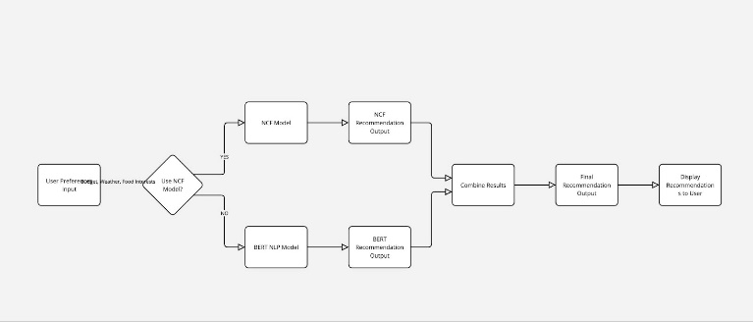

Figure 3: Flowchart of Recommendation Engine showing data flow through NCF and BERT models

1. *Database Management*

MongoDB stores user preferences, interaction histories, and real-time updates. This NoSQL database will assure speed when the data retrieves to keep the scalability and performance needs of DestinEase unabated. Database structuring was done with data privacy regulation for safe handling.

1. **Testing and Evaluation**
2. Recommendation Accuracy: Confirmed recommendations will align with the users' choices concerning budget, weather, and food interests.
3. Live Data: Accuracy of Live Weather and Pricing Data.
4. Responsive Design: accessible across devices, tested on multi-devices.
5. Data Security Compliance: Followed every regulation about secure storage.
   1. ***Evaluation Metrics***

This involved measuring metrics such as relevance of recommendations, user engagement, system response time, and accuracy of data. Test results showed that the satisfaction of the users was high, recommendations correctly reflected user preferences, and real-time data integration was reliably updated, hence improving user experience.

1. **Product Results**

Testing showed that DestinEase results in relevant, personalized travel recommendations, which pertinently matches the preference of an end-user. Feedback by the users, however, confirmed that every recommendation was contextually appropriate and reachable. Real-time integration of data, regarding weather or pricing, came to be quite accurate and helpful to support decision-making.

1. **Conclusion**

DestinEase is an integrated AI travel recommendation system that does destinations according to user preference, amalgamated with real-time data. This has been coupled with Neural Collaborative Filtering and BERT for recommendations on a personalized basis. The recommendations of this algorithm may be further extended in the future by integrating more and more travel-related data and fine-tuning the user feedback mechanism for better personalization. With DestinEase, the travel planning enters a whole new dimension where the user is provided with data-driven personalization for traveling.

References

1. He, X., Liao, L., Zhang, H., Nie, L., Hu, X., & Chua, T. (2017). "Neural Collaborative Filtering." *Proceedings of the 26th International Conference on World Wide Web*, 173-182.
2. Devlin, J., Chang, M. W., Lee, K., & Toutanova, K. (2019). "BERT: Pre-training of deep bidirectional transformers for language understanding." *Proceedings of NAACL-HLT 2019*.
3. Silver, D., Huang, A., Maddison, C. J., et al. (2016). "Mastering the game of Go with deep neural networks and tree search." *Nature*, 529(7587), 484-489.
4. Watanabe, C. (2016). "Emerging on-demand service platforms." *Journal of Service Research*, 18(4), 567-585.
5. Choi, S., He, X., & Lee, H. (2021). "Dynamic Pricing with Reinforcement Learning: A Survey." *IEEE Transactions on Neural Networks and Learning Systems*, 32(12), 5257-5274.